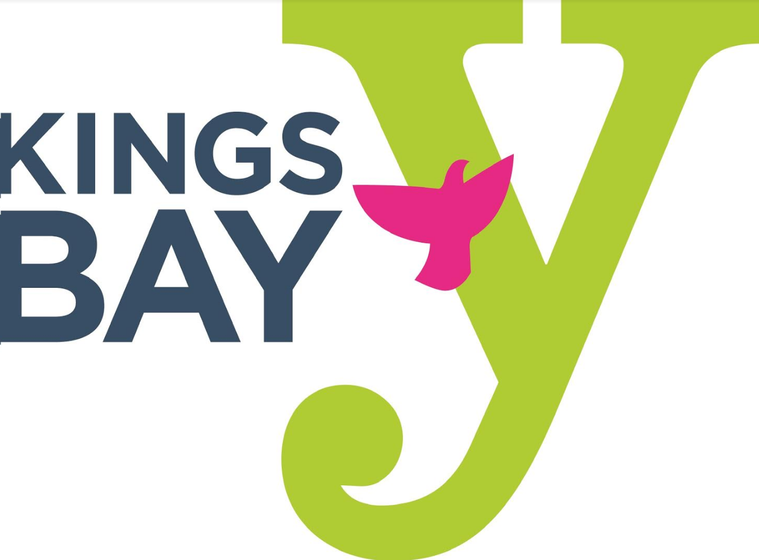
KINGS BAY YM-YWHA HOLIDAY CLOSURES
JULY 2025 - JUNE 2026

JULY
Friday, July 4, 2025 Independence Day – Closed
SEPTEMBER
Monday, September 1, 2025 Labor Day – Closed
OCTOBER
Tuesday, September 23, 2025 Rosh Hashanah – Closed
Wednesday, September 24, 2025 Rosh Hashanah – Closed
Thursday, October 2, 2025 Yom Kippur – Closed
Monday, October 13, 2025 Columbus Day - Closed
NOVEMBER
Thursday, November 27, 2025 Thanksgiving Day – Closed
JANUARY
Thursday, January 1, 2026 New Year’s Day – Closed
Monday, January 19, 2026 Martin Luther King Day - Closed
FEBRUARY
Monday, February 16, 2026 Presidents Day - Closed
APRIL
Thursday, April 2, 2026 Passover – Closed
Friday, April 3, 2026 Passover – Closed
MAY
Monday, May 25, 2026 Memorial Day – Closed

Note: Religious holidays falling on the weekend are NOT considered paid holidays

