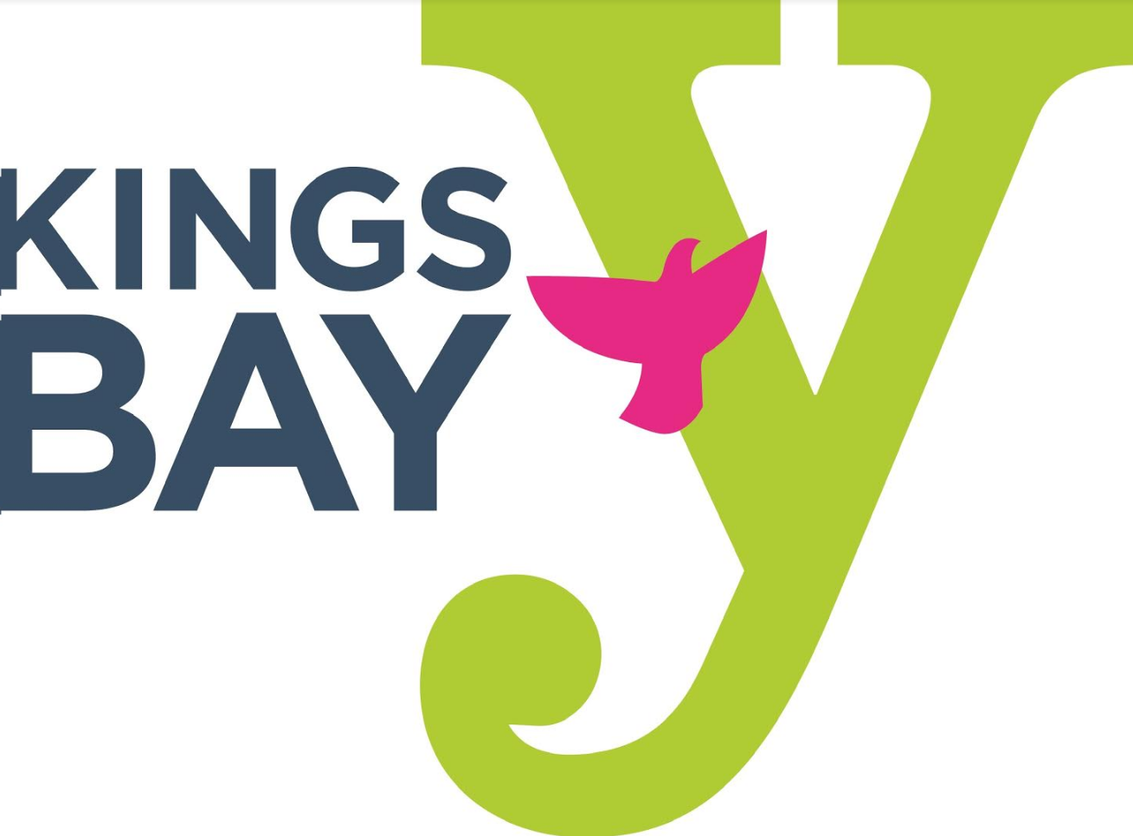
KINGS BAY YM-YWHA HOLIDAY CLOSURES
JULY 2024 - JUNE 2025

JULY
Thursday, July 4, 2024 Independence Day – Closed
SEPTEMBER
Monday, September 2, 2024 Labor Day – Closed
OCTOBER
Thursday, October 3, 2024 Rosh Hashanah – Closed
Friday, October 4, 2024 Rosh Hashanah – Closed
Saturday, October 12, 2024 Yom Kippur – Closed
Monday, October 14, 2024 Columbus Day - Closed
NOVEMBER
Thursday, November 28, 2024 Thanksgiving Day – Closed
JANUARY
Wednesday, January 1, 2025 New Year’s Day – Closed
Monday, January 20, 2025 Martin Luther King Day - Closed
FEBRUARY
Monday, February 17, 2025 Presidents Day - Closed
APRIL
Sunday, April 13, 2025 Passover – Closed
Monday, April 14, 2025 Passover – Closed
MAY
Monday, May 26, 2025 Memorial Day – Closed

Note: Religious holidays falling on the weekend are NOT considered paid holidays

