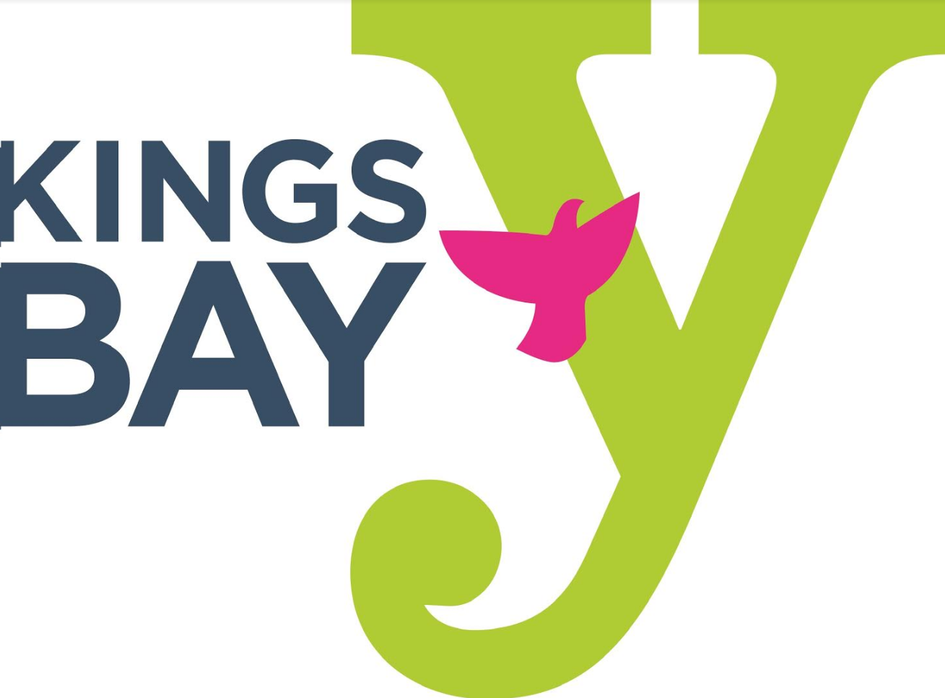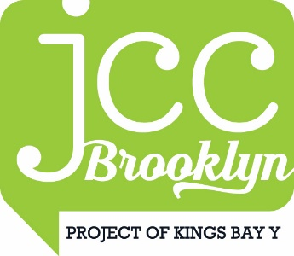
KINGS BAY YM-YWHA HOLIDAY CLOSURES
JULY 2021 - JUNE 2022
JULY
Monday, July 5, 2021 Independence Day – Y Closed
SEPTEMBER
Monday, September 6, 2021 Labor Day – Y Closed
Tuesday, September 7, 2021 Rosh Hashanah – Y Closed
Wednesday, September 8, 2021 Rosh Hashanah – Y Closed
Wednesday, September 15, 2021 Y Closes at 6:00 pm for Yom Kippur
Thursday, September 16, 2021 Yom Kippur – Y Closed
OCTOBER
Monday, October 11, 2021 Columbus Day/Indigenous People’s Day – Y Closed
NOVEMBER
Thursday, November 25, 2021 Thanksgiving Day – Y Closed
JANUARY
Saturday, January 1, 2022 New Year Day – Y Closed
Monday, January 17, 2022 Martin Luther King Day – Y Closed
FEBRUARY
Monday, February 21, 2022 Presidents Day – Y Closed
APRIL
Friday, April 15, 2022 Y Closes at 6:00 pm for Passover
Saturday, April 16, 2022 Passover – Y Closed
Sunday, April 17, 2022 Passover – Y Closed
MAY
Monday, May 30, 2022 Memorial Day – Y Closed

