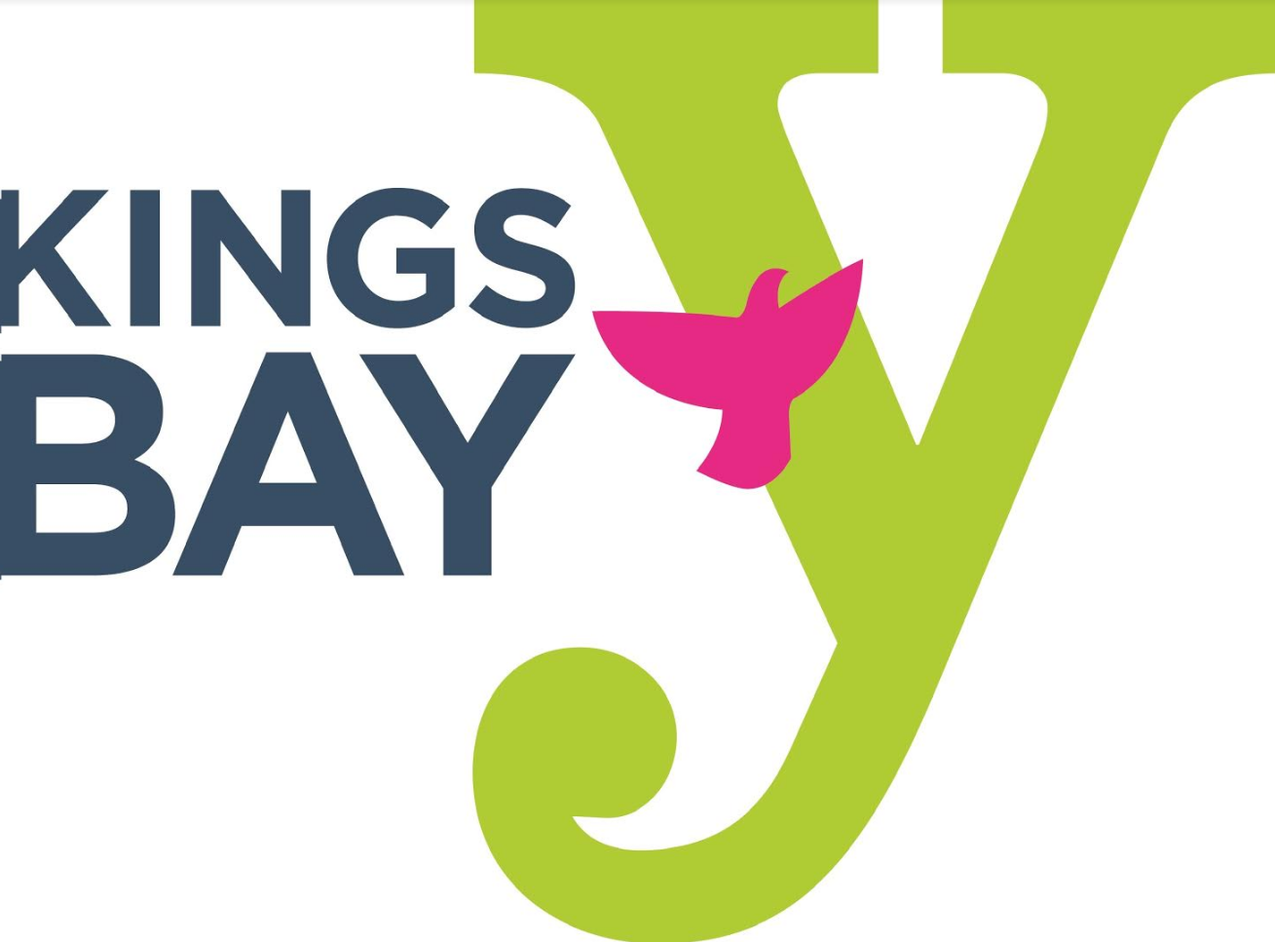
KINGS BAY YM-YWHA HOLIDAY CLOSURES
JULY 2020 - JUNE 2021
JULY
Friday, July 3, 2020 Independence Day – Y Closed
SEPTEMBER
Monday, September 7, 2020 Labor Day – Y Closed
Friday, September 18, 2020 Y Closes at 6:00 pm for Rosh Hashanah
Saturday, September 19, 2020 Rosh Hashanah – Y Closed
Sunday, September 20, 2020 Rosh Hashanah – Y Closed
Sunday, September 27, 2020 Y Closes at 6:00 pm for Yom Kippur
Monday, September 28, 2020 Yom Kippur – Y Closed
OCTOBER
Monday, October 12, 2020 Columbus Day – Y Closed
NOVEMBER
Thursday, November 26, 2020 Thanksgiving Day – Y Closed
JANUARY
Friday, January 1, 2021 New Year Day – Y Closed
Monday, January 18, 2021 Martin Luther King Day – Y Closed
FEBRUARY
Monday, February 17, 2021 Presidents Day – Y Closed
APRIL
Wednesday, April 8, 2021 Y Closes at 6:00 pm for Passover
Thursday, April 9, 2021 Passover – Y Closed
Friday, April 10, 2021 Passover – Y Closed
MAY
Monday, May 31, 2021 Memorial Day – Y Closed

