Origami Finger Puppet Tutorial - Step 1

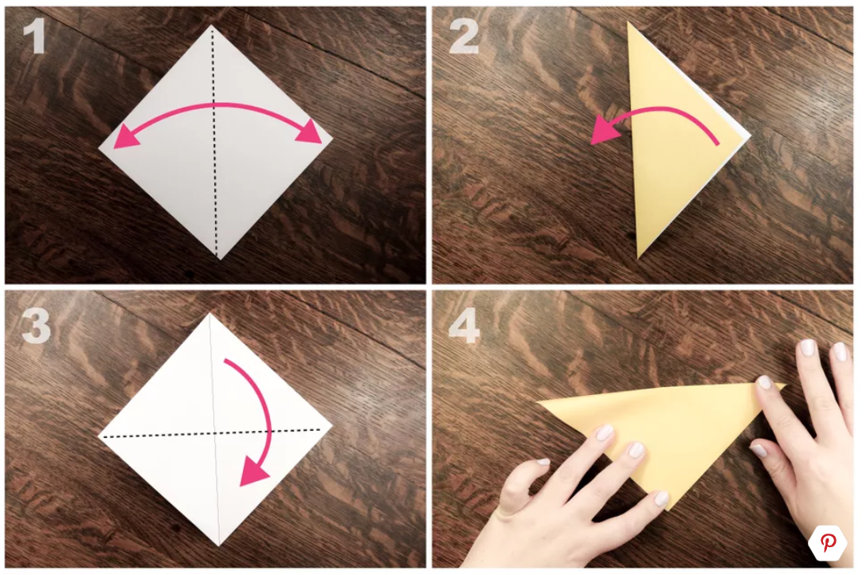
Start white side up.
1. Fold in half vertically.
2. Unfold.
3. Fold in half horizontally.

Origami Finger Puppet Tutorial - Step 2

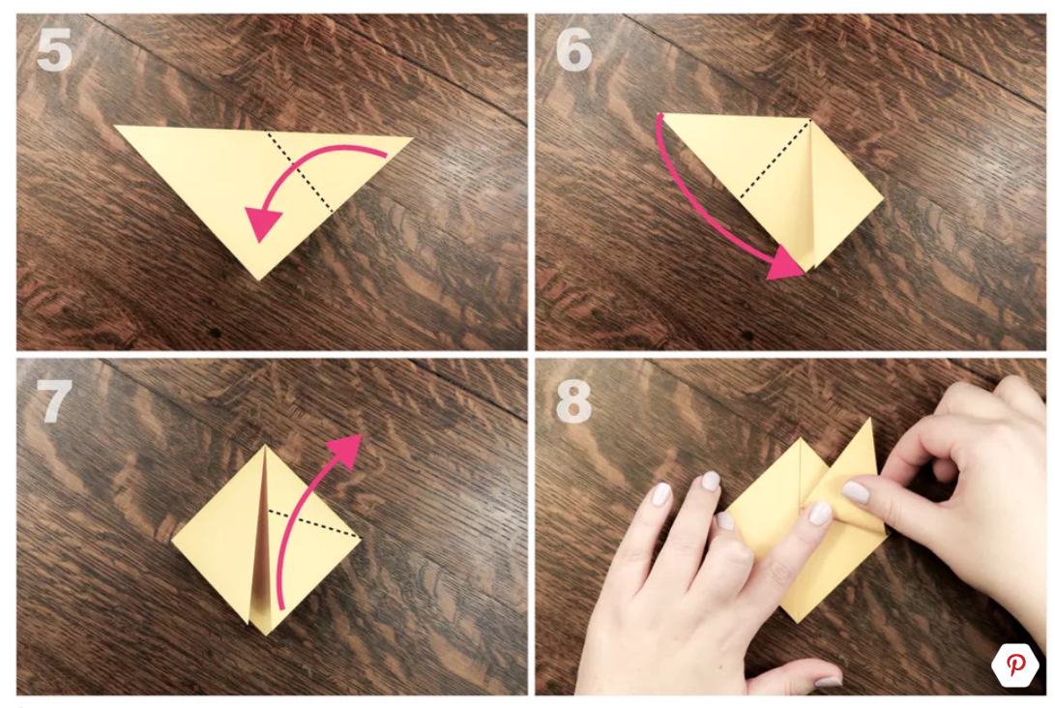
5. Fold the right corner down to the bottom center point.
6. Fold the left corner down to the bottom center point.
7. Fold the right flap up from the center as shown.
8. Roughly position the flap with the right edge at a ​90-degree angle.

Origami Finger Puppet Tutorial - Step 3

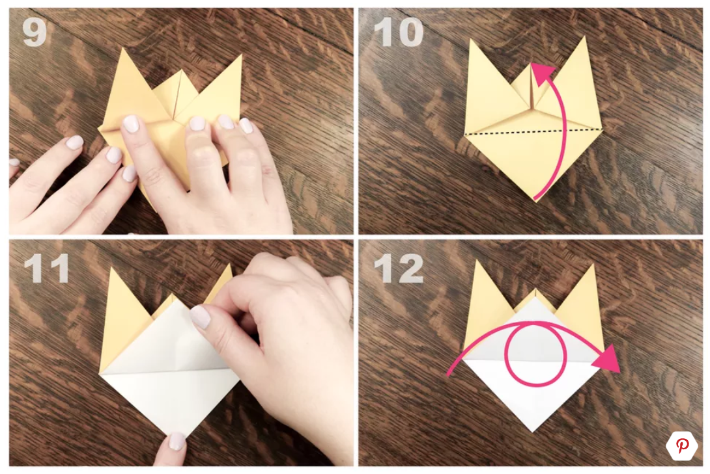
9. Fold the left flap in the same way as the right.
10 & 11. Fold one layer from the bottom section up to the top point.
12. Turn the model over.

Origami Finger Puppet Tutorial - Step 4

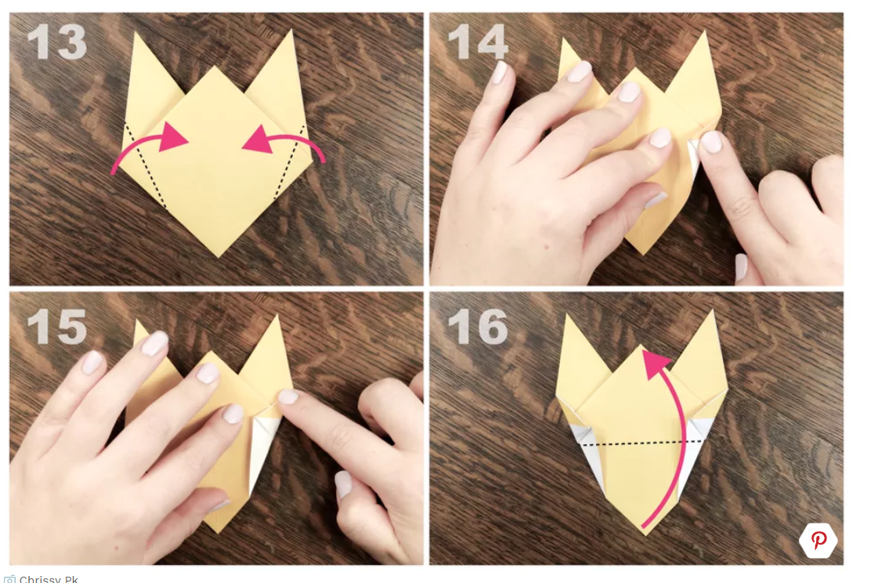
13. Fold the left and right edges inwards as shown in #14 & 15.
16. Fold the bottom section up to the top point.

Origami Finger Puppet Tutorial - Step 5

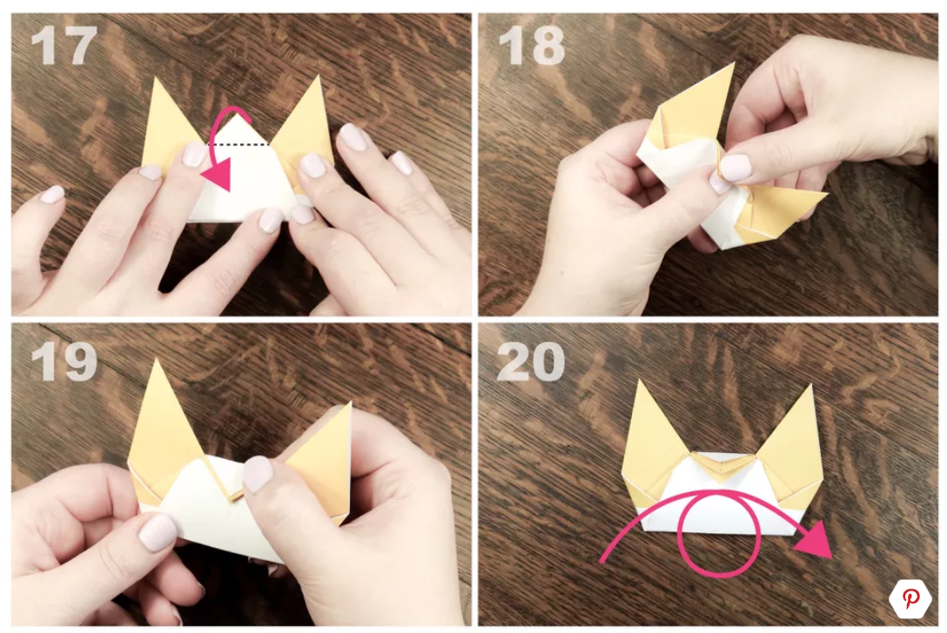
17 - 19. Fold the top section down, including all layers.
You could stick these down if you like.
20. Turn the model over.

Origami Finger Puppet Tutorial - Step 6

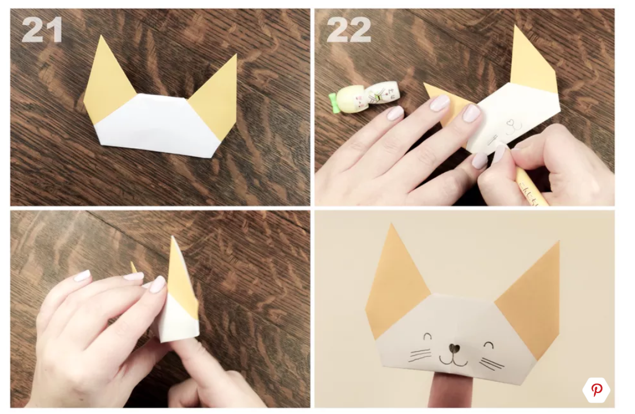
21 & 22. Draw a cute face!
Your cute little finger puppet it finished!
Don't worry if it didn't work out the first time, just try again, it can take practice.

