Instructions
Begin this easy pinwheel craft by gathering several pieces of your child’s art. Cut each piece into a 4″x 4″ or 5″x 5″ square. Next fold the square in half at the corners, making a triangle. Unfold and repeat the this step from the other corner. This should give you an “X” shape on your paper when you unfold it.

Using scissors, make four diagonal cuts on the folded lines of the “X” toward the paper’s center. Stop at least half an inch from the center.
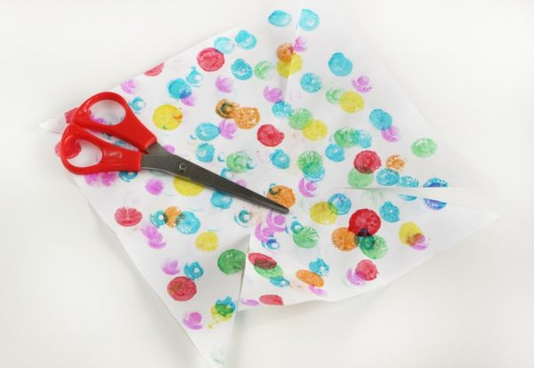
Next fold the corner to the left of each cut into the center. Hold the folded points in place while you push a brass fastener through the center or use a hole punch to create a hole and then slide the brass fastener through it. Make sure that you puncture all four folded corners, you will need all four in order for your pinwheel to be formed. Twist the artwork back and forth around the brass fastener a few times until the paper slides easy back and forth. This ensures your pinwheel will be able to turn in the wind.
If the artwork you are recycling is just one sided flip it over, art side down, before beginning this step. Doing this allows the colored portions of the artwork to be seen.
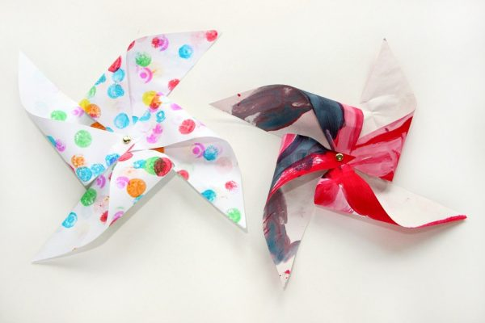
Wrap the ends of the brass fastener around the wooden dowel. Make sure they are tight to avoid your pinwheel sliding down to the bottom of the dowel.
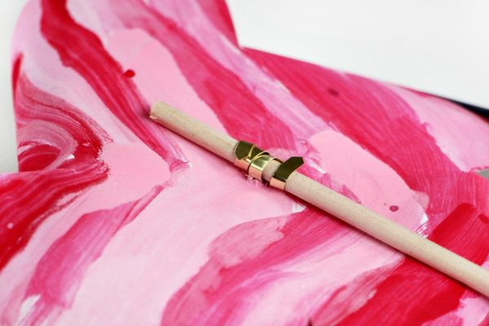
That’s the last step! Give it a try, blow on the pinwheel and watch it spin! Now your pinwheel craft is ready to find it’s new home in your garden.

