Watercolor Resist Preschool & Toddler Art
What we used:
- Oil Pastels
- Liquid Watercolors
- Painters Tape
- Construction Paper
I started the project by putting two strips of tape on the paper then gave the kids the tape and she placed the strips where she wanted. When all the tape was down she picked out some oil pastels and started coloring.
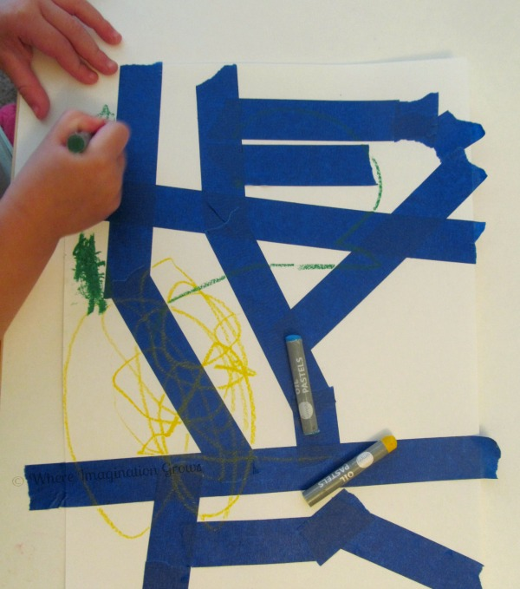
After the oil pastels we got out our liquid watercolors and she painted over her picture and the tape with it.
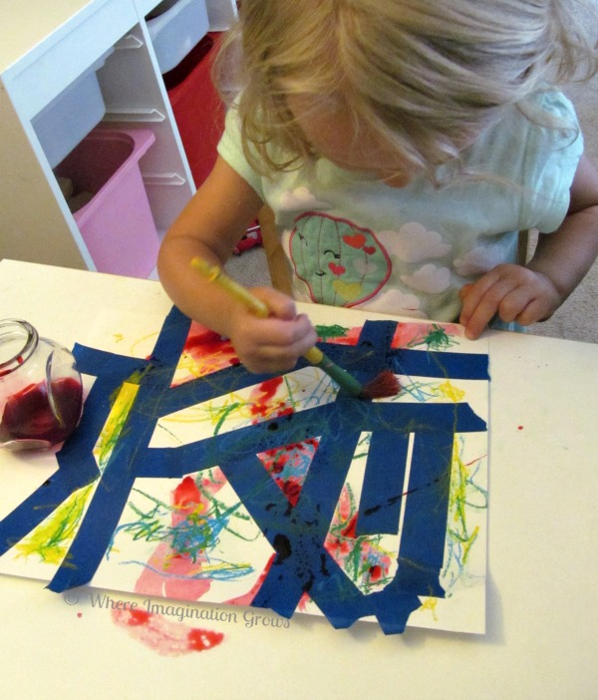
When they fished painting it I used a paper towel to absorb some of the excess watercolors. Then it was time to pull off the tape.

